
Data Flow
AI Resume Analyzer and Job Matcher
CSCI 5411 – Advanced Cloud Computing

Submitted By: Dhruti Patel (B01060910)

Diagram

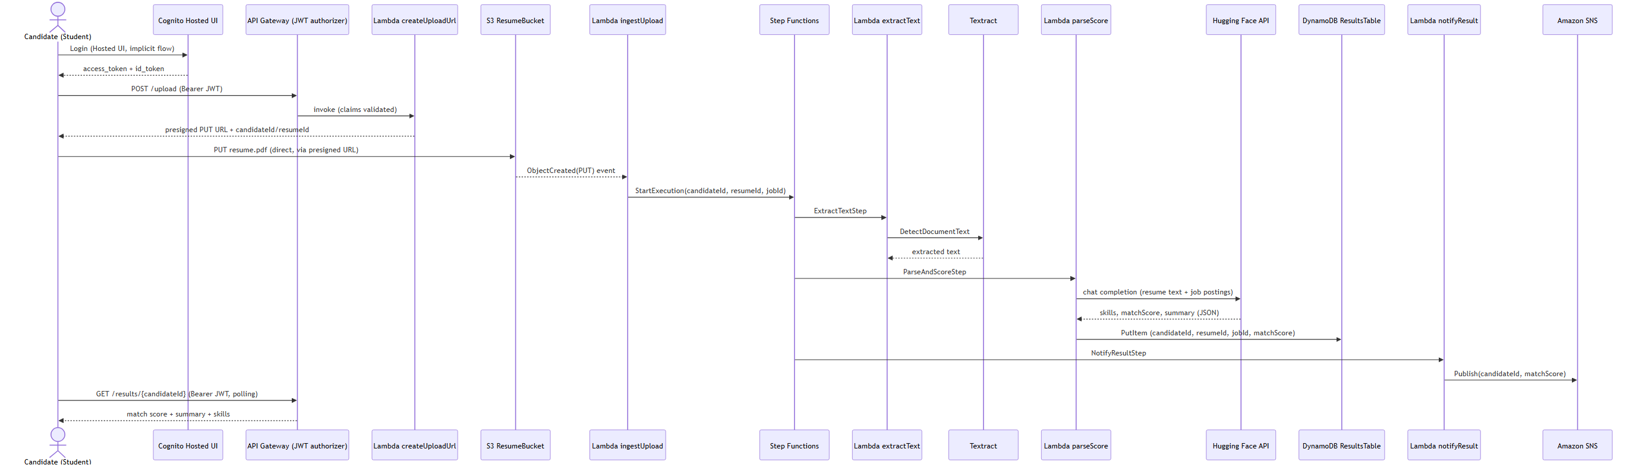
Figure 2. Sequence diagram for the critical resume-upload-to-notification path.

Sequence
The table below traces the student self-upload path shown in Figure 2, step by step, from login through receiving a result.
Step | From | To | Action
1 | Candidate | Cognito Hosted UI | Login (Hosted UI, implicit OAuth flow).
2 | Cognito Hosted UI | Candidate | Returns access_token + id_token in the URL fragment.
3 | Candidate | API Gateway | POST /upload, Bearer JWT attached.
4 | API Gateway | Lambda createUploadUrl | Invokes the Lambda after the JWT authorizer validates the token's claims.
5 | Lambda createUploadUrl | Candidate | Returns a presigned S3 PUT URL plus the generated candidateId/resumeId.
6 | Candidate | S3 ResumeBucket | PUTs resume.pdf directly to S3 using the presigned URL (not through API Gateway).
7 | S3 ResumeBucket | Lambda ingestUpload | S3 ObjectCreated(PUT) event invokes the Lambda.
8 | Lambda ingestUpload | Step Functions | StartExecution(candidateId, resumeId, jobId) on ResumeAnalysisStateMachine.
9 | Step Functions | Lambda extractText -> Textract | ExtractTextStep calls Textract DetectDocumentText on the S3 object.
10 | Step Functions | Lambda parseScore -> Hugging Face API | ParseAndScoreStep scores the extracted text against JobsTable postings and writes the result to ResultsTable.
11 | Step Functions | Lambda notifyResult -> SNS | NotifyResultStep publishes a completion message (candidateId, matchScore) to the SNS topic.
12 | Candidate | API Gateway | GET /results/{candidateId}, Bearer JWT, polled every 5s for up to 2 minutes.
13 | API Gateway | Candidate | Returns match score, skill tags, and summary once analysis has completed.

Recruiter Bulk-Upload Variant
A recruiter's bulk upload follows the identical S3-to-Step-Functions pipeline shown in steps 6-11 above, run once per uploaded resume. The only differences are: (a) the upload is initiated from the Office console rather than the Student console, (b) the recruiter supplies a jobId, which createUploadUrl encodes into the S3 object key (resumes/{candidateId}/{jobId}/{resumeId}.pdf) instead of defaulting to "general", and (c) the recruiter retrieves results via GET /jobs/{jobId}/results (a ranked leaderboard for that job) rather than polling a single candidateId.

Registration & Role Assignment
Both students and recruiters self-register through the same sign-up form; the role picked on that form determines which Cognito group (students or recruiters) the post-confirmation Lambda assigns them to, which in turn drives which dashboard and API permissions they get on every subsequent request.
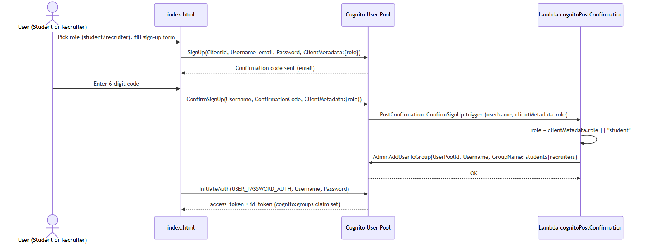
Figure 3. Sequence diagram for self-registration and Cognito group assignment.
Step | From | To | Action
1 | User | index.html | Picks role (student/recruiter) and fills out the sign-up form.
2 | index.html | Cognito User Pool | SignUp(ClientId, Username=email, Password, ClientMetadata:{role}).
3 | Cognito User Pool | index.html | Sends a 6-digit confirmation code to the user’s email.
4 | User | index.html | Enters the confirmation code.
5 | index.html | Cognito User Pool | ConfirmSignUp(Username, ConfirmationCode, ClientMetadata:{role}).
6 | Cognito User Pool | Lambda cognitoPostConfirmation | PostConfirmation_ConfirmSignUp trigger fires with the userName and clientMetadata.role.
7 | Lambda cognitoPostConfirmation | Lambda cognitoPostConfirmation | Resolves role = clientMetadata.role, defaulting to “student” if absent.
8 | Lambda cognitoPostConfirmation | Cognito User Pool | AdminAddUserToGroup(UserPoolId, Username, GroupName: students or recruiters).
9 | index.html | Cognito User Pool | InitiateAuth(USER_PASSWORD_AUTH, Username, Password) to sign in immediately after confirmation.
10 | Cognito User Pool | index.html | Returns access_token + id_token, now carrying the cognito:groups claim used for routing and authorization.

Sign-up and confirmation errors (UsernameExistsException, InvalidPasswordException, CodeMismatchException, ExpiredCodeException) are surfaced to the user inline on the form. The Cognito-to-Lambda invocation is authorized by a resource-based Lambda permission scoped to the cognito-idp.amazonaws.com principal and the specific user pool ARN.

Recruiter Job-Posting Creation
Recruiters create job postings from the Office console’s add-job modal. The write path is authorized twice: once by the shared JWT authorizer on the API route, and again inside the Lambda, which checks that the caller’s cognito:groups claim actually contains recruiters before writing to JobsTable.

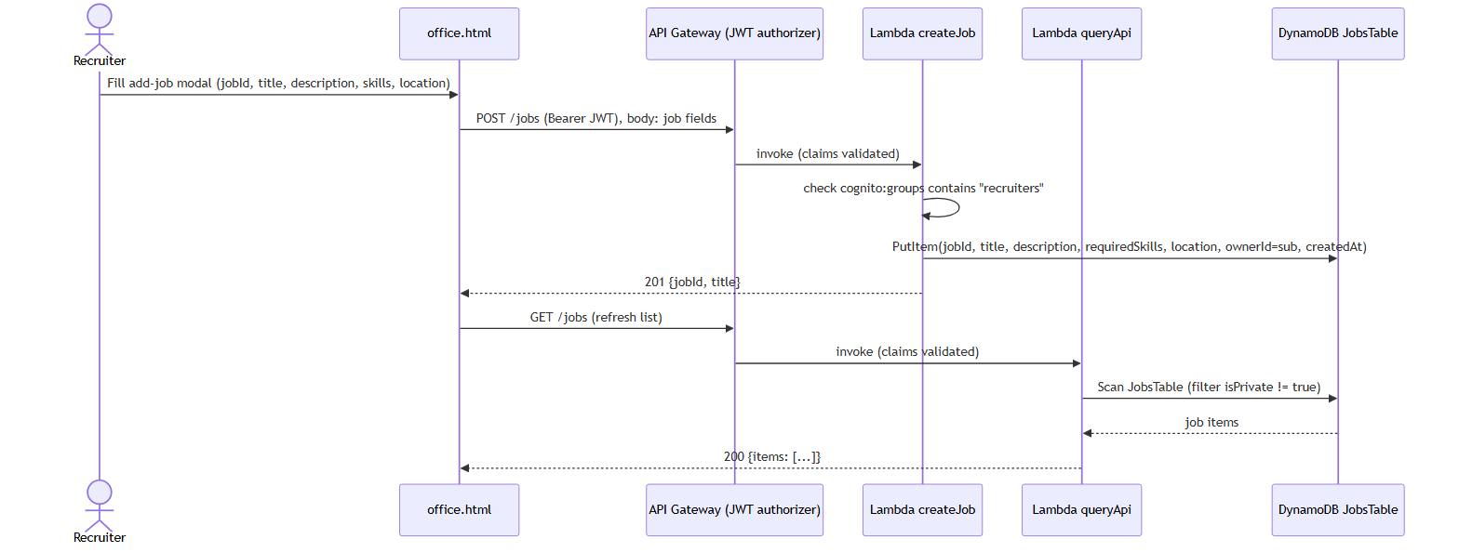
Figure 4. Sequence diagram for a recruiter creating a job posting.
Step | From | To | Action
1 | Recruiter | office.html | Fills the add-job modal: jobId, title, description, skills, location.
2 | office.html | API Gateway | POST /jobs, Bearer JWT attached, body carries the job fields.
3 | API Gateway | Lambda createJob | Invokes the Lambda after the JWT authorizer validates the token’s claims.
4 | Lambda createJob | Lambda createJob | Checks that cognito:groups contains recruiters; returns 403 otherwise.
5 | Lambda createJob | DynamoDB JobsTable | PutItem(jobId, title, description, requiredSkills, location, ownerId=sub, createdAt).
6 | Lambda createJob | office.html | Returns 201 {jobId, title} on success, or 400 if jobId/title are missing.
7 | office.html | API Gateway | GET /jobs to refresh the jobs grid.
8 | API Gateway | Lambda queryApi | Invokes the Lambda after the JWT authorizer validates the token’s claims.
9 | Lambda queryApi | DynamoDB JobsTable | Scans JobsTable, filtering out items marked isPrivate.
10 | Lambda queryApi | office.html | Returns 200 {items: [...]} with the current job postings.

There is no dedicated “listJobs” Lambda — the same queryApi function that serves GET /results/{candidateId} and GET /my-results also serves GET /jobs. Job listing and creation are handled by two separate Lambdas (queryApi and createJob respectively) behind the same JWT-authorized API.

Resume / PDF Download
Recruiters download a candidate’s resume from a job’s ranking view; candidates download their own resume from their result history. Both paths resolve to a short-lived S3 presigned GET URL generated server-side — the browser’s actual file download goes directly to S3, bypassing API Gateway and Lambda entirely.

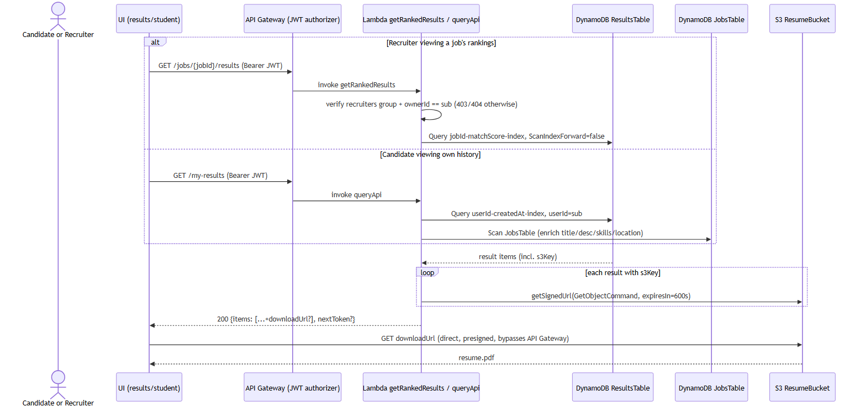
Figure 5. Sequence diagram for downloading a resume PDF.
Step | From | To | Action
1a | Recruiter | API Gateway | GET /jobs/{jobId}/results, Bearer JWT.
2a | API Gateway | Lambda getRankedResults | Invokes the Lambda; it verifies the caller is in recruiters and owns the job (403/404 otherwise).
3a | Lambda getRankedResults | DynamoDB ResultsTable | Query on the jobId-matchScore-index GSI, sorted highest score first.
1b | Candidate | API Gateway | GET /my-results, Bearer JWT.
2b | API Gateway | Lambda queryApi | Invokes the Lambda; queries the userId-createdAt-index GSI for the caller’s own results.
3b | Lambda queryApi | DynamoDB JobsTable | Scans JobsTable to enrich each result with job title, description, skills, and location.
4 | Lambda getRankedResults / queryApi | S3 ResumeBucket | For each result with an s3Key, generates a presigned GET URL (getSignedUrl, 600s expiry).
5 | Lambda getRankedResults / queryApi | UI | Returns 200 {items: [...+downloadUrl?], nextToken?}; downloadUrl is omitted if s3Key is missing or presigning fails.
6 | UI | S3 ResumeBucket | Browser follows the presigned URL directly to S3 to fetch resume.pdf, bypassing API Gateway.

The s3Key on each result record is written earlier in the pipeline by the parseScore Lambda during scoring, not by the download path itself. If a result has no s3Key, the UI shows a placeholder instead of a download link rather than erroring.

Scheduled Job Refresh
An EventBridge rule invokes the refreshJobs Lambda once every 24 hours to seed a fixed set of baseline job postings into JobsTable, independent of and alongside whatever live postings recruiters create through POST /jobs.

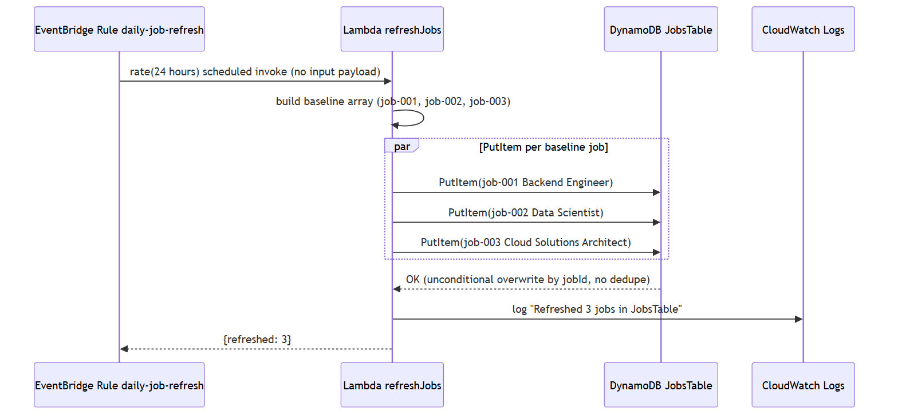
Figure 6. Sequence diagram for the daily baseline job-posting refresh.
Step | From | To | Action
1 | EventBridge Rule daily-job-refresh | Lambda refreshJobs | rate(24 hours) scheduled invocation; no input payload.
2 | Lambda refreshJobs | Lambda refreshJobs | Builds a hardcoded array of 3 baseline jobs (job-001, job-002, job-003) with title, description, requiredSkills, and location.
3 | Lambda refreshJobs | DynamoDB JobsTable | Issues a PutItem per baseline job in parallel; each unconditionally overwrites the existing item for that jobId.
4 | Lambda refreshJobs | CloudWatch Logs | Logs “Refreshed 3 jobs in JobsTable”.
5 | Lambda refreshJobs | EventBridge Rule daily-job-refresh | Returns {refreshed: 3}.

There is no dedupe or conditional check on the PutItem calls — if a recruiter ever creates a job reusing job-001, job-002, or job-003 as its jobId, the next scheduled refresh silently overwrites it with the baseline posting.

